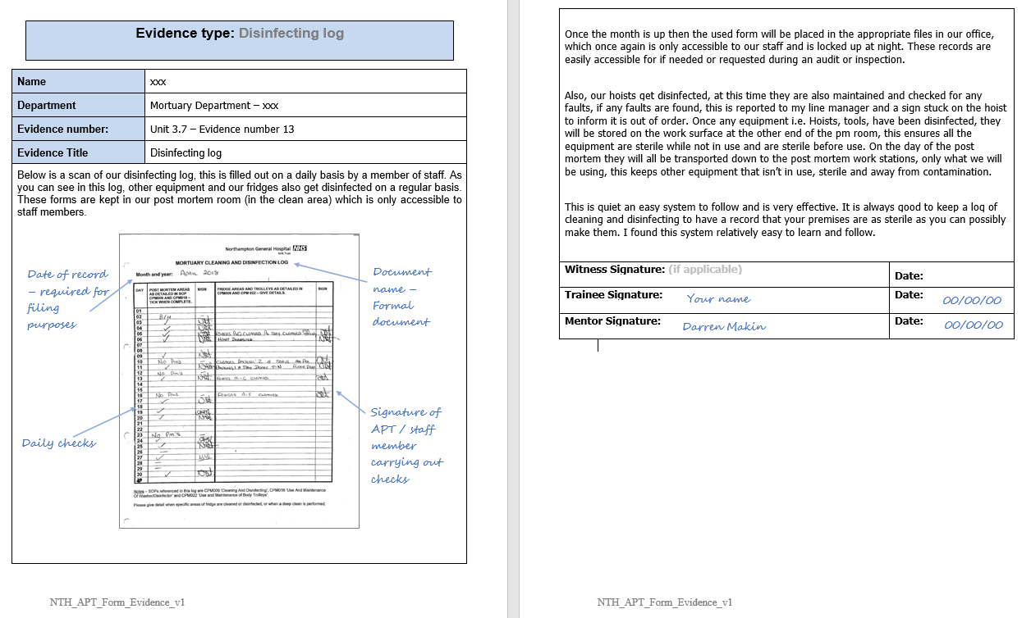
Good example: This piece of evidence demonstrates decontamination records (Preparation and operation of a mortuary)

Do not included entire documents or multiple pages in your portfolio – for example use screen shots, front copies of SOPs or an example of a record sheet in use. Always explain what the piece of evidence is and how it is used (i.e. put into context).
Good example: This piece of evidence demonstrates temperature monitoring checks (Preparation and operation of a mortuary)
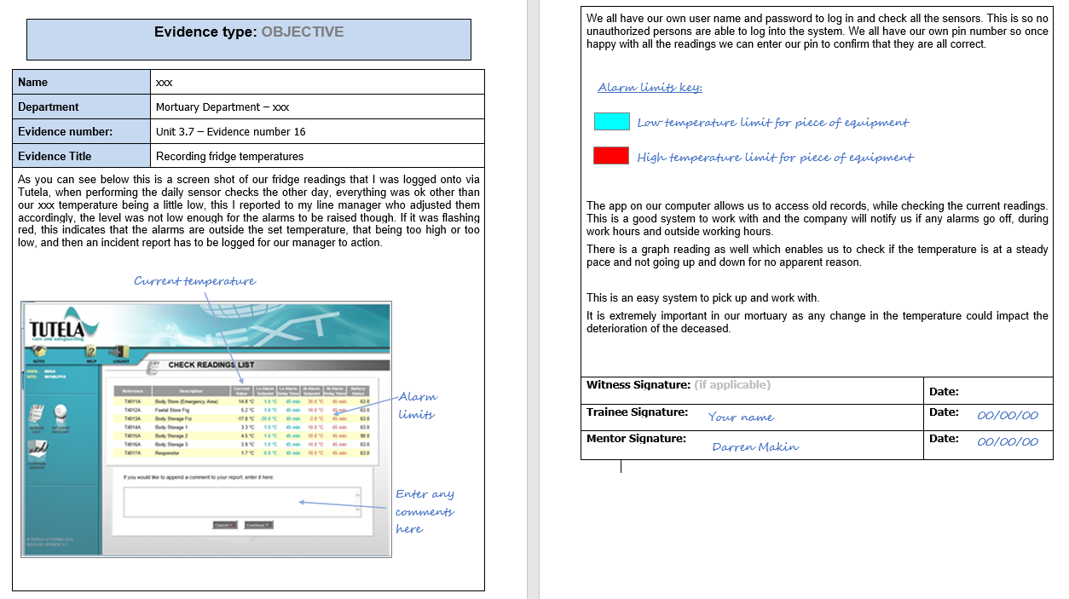

It is good practice for candidates to annotate pieces of work
Good example: This piece of evidence shows an SOP record for local cleaning procedures (Preparation and operation of a mortuary)
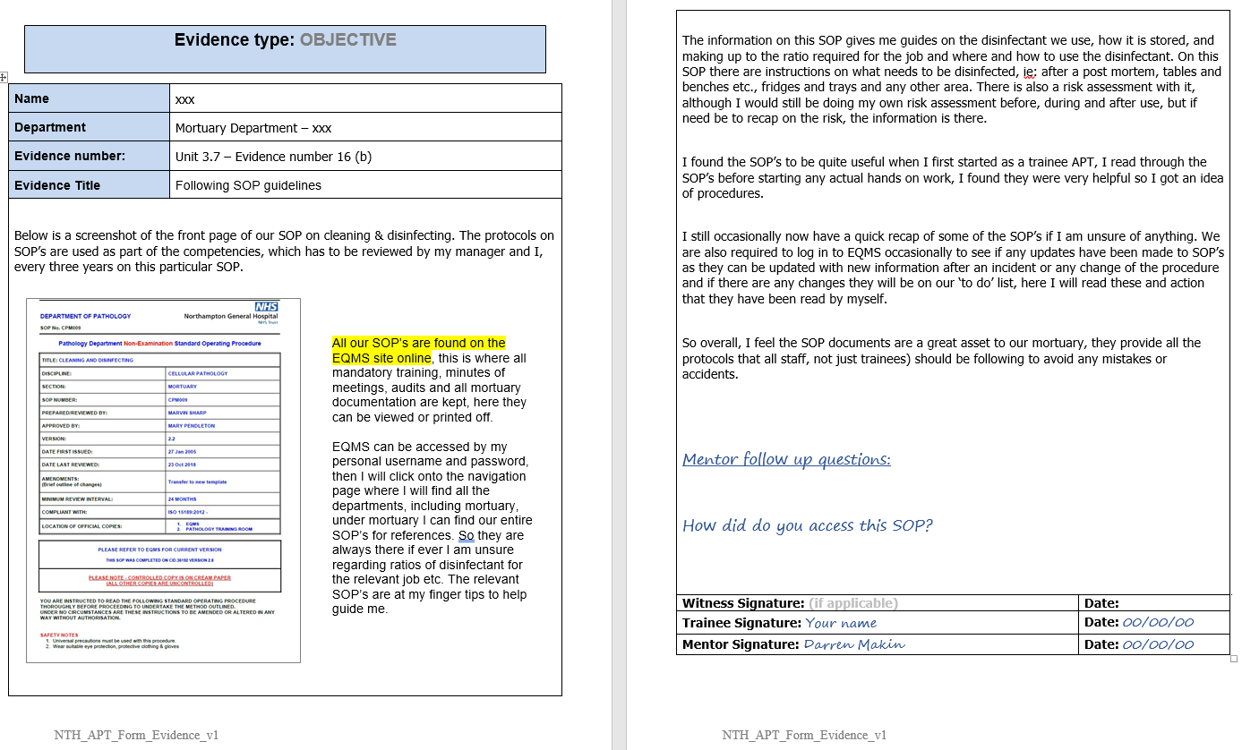

It is good practice for mentors to ask follow up questions or leave comments on a candidate’s piece of work. Candidates should not rewrite the piece of evidence to include answers to set questions – an additional sheet or hand-written notes of the original evidence piece is acceptable.
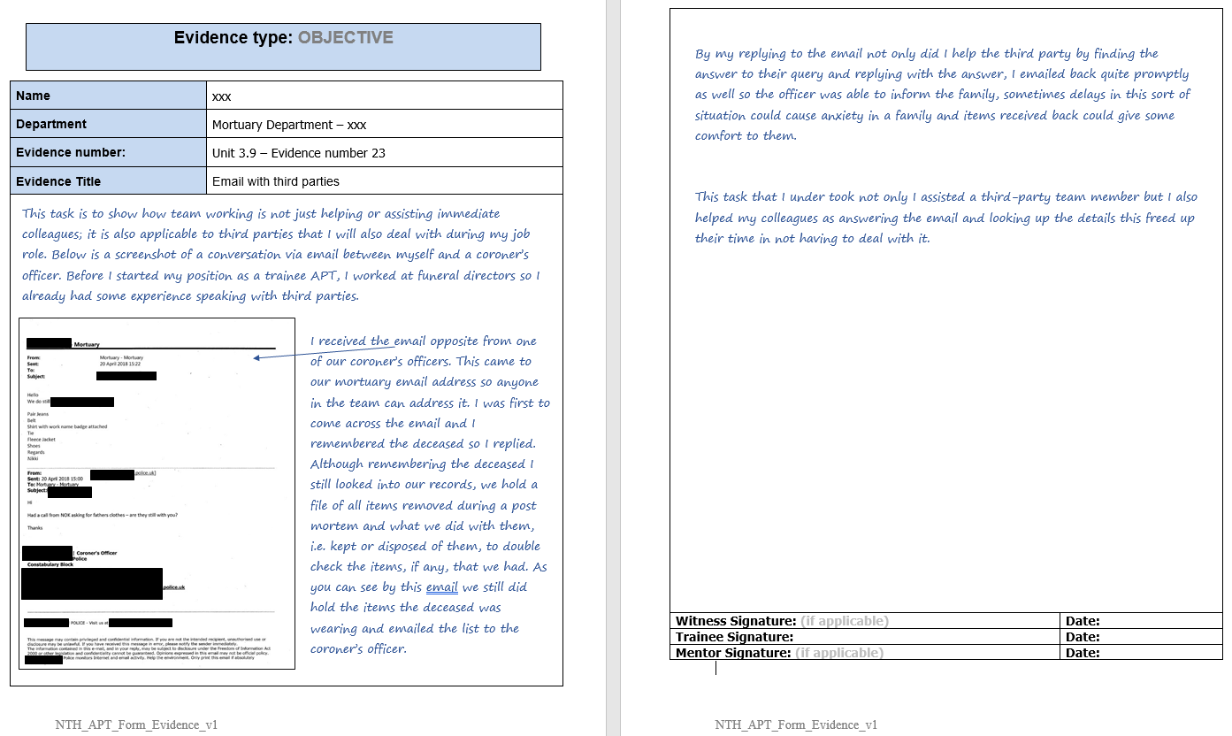
Good example: This piece of evidence demonstrates communication between organisations (Team working)

Ensure there is no identifiable data in you evidence (including patient details)
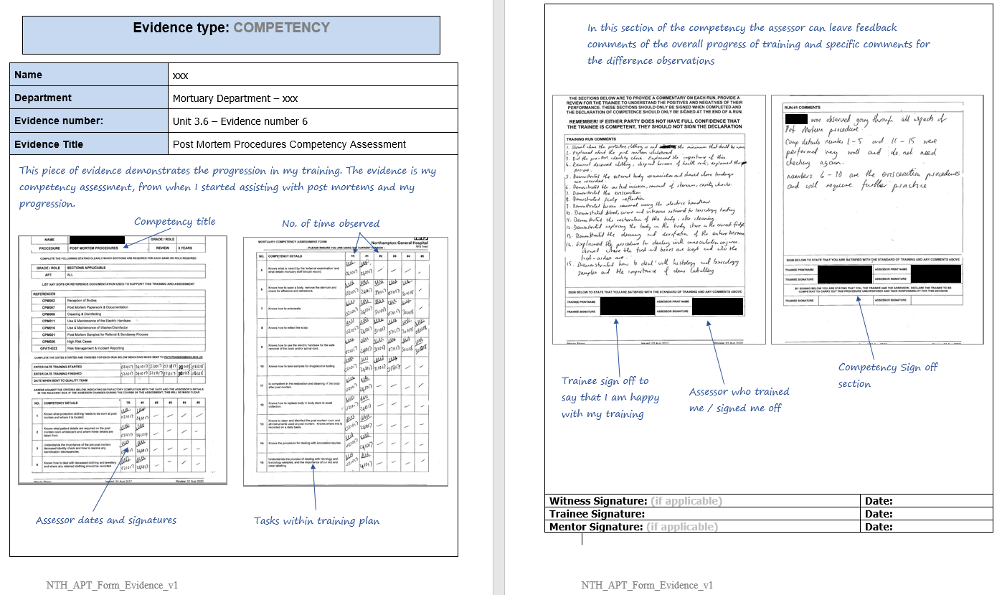
Good example: This piece of evidence demonstrates competency for Post Mortems (Assist with post mortem examinations)

Good example: This piece of evidence demonstrates shows a local document for viewing appointments (Viewing of the deceased)
